# **Three Phase Uncontrolled Rectifier with Capacitor Filter**

--------------------------------------------------------------------------------------------------------------------------

This task is aimed to analyze the effect of capacitor filter or smoothing capacitor on rectified output voltage for three phase uncontrolled rectifiers. The circuit is implemented in simulation through matlab simulink

## **Learning Outcomes**

### **Concept of Smoothing Capacitor**

We saw in the previous task that the single phase half-wave rectifier produces an output wave every half cycle and that it was not practical to use this type of circuit to produce a steady DC supply. The full-wave bridge rectifier however, gives us a greater mean DC value with less superimposed ripple while the output waveform is twice that of the frequency of the input supply frequency. We can therefore increase its average DC output level even higher by connecting a suitable smoothing capacitor across the output of the bridge circuit .

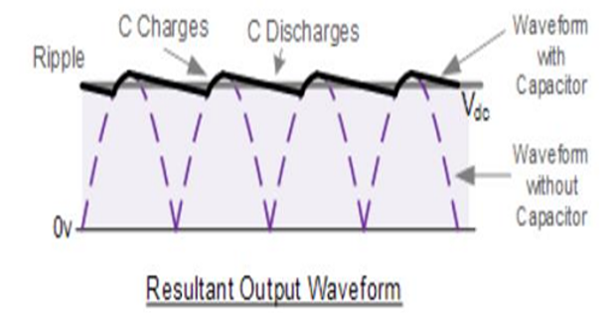

The smoothing capacitor converts the full-wave rippled output of the rectifier into a smooth DC output voltage. Generally for DC power supply circuits the smoothing capacitor is an Aluminum Electrolytic type that has a capacitance value of 100µF or more.

However, there are two important parameters to consider when choosing a suitable smoothing capacitor and these are its Working Voltage, which must be higher than the no-load output value of the rectifier and its Capacitance Value, which determines the amount of ripple that will appear superimposed on top of the DC voltage.

Too low a capacitance value and the capacitor has little effect on the output waveform. But if the smoothing capacitor is sufficiently large enough (parallel capacitors can be used) and the load current is not too large, the output voltage will be almost as smooth as pure DC.

### **Calculation**

Form Factor = Vrms / Vdc

Ripple Factor = √(FF² − 1)

For a three-phase rectifier, the capacitor is sized based on **load current (I_load)** and acceptable **ripple voltage (ΔV_ripple)**.

## **C = I_load / (6 * f * ΔV_ripple)**

where:

* C= Capacitor value (Farads)
* I_LOAD= Load current (Amps)
* f = AC supply frequency (Hz) (Here, **50 Hz**)
* ΔV-ripple​ = Allowable ripple voltage (Volts)

**Simulation of Full Wave Three Phase Diode Rectifier with C Filter**

**graph:**

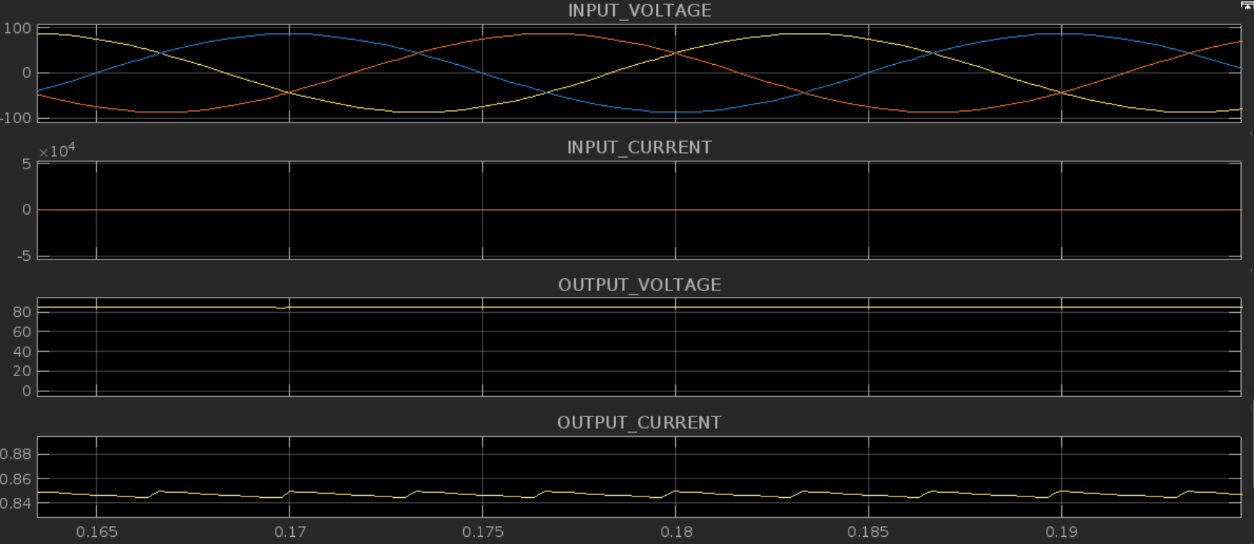

## **Simulink layout of Full Wave Single Phase Diode Rectifier with C Filter**

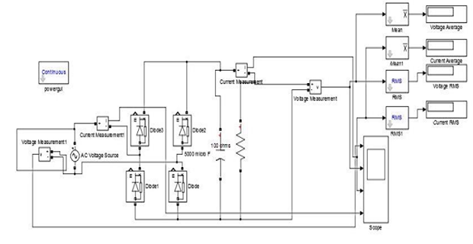

Capacitor value: 5000e-6 F

Load Resistance value: 100 ohm

INPUT Voltage: 61.2 v Phase-to-phase voltage (Vrms)

Frequency: 50 hertz.

|  | Three Phase |
| --- | --- |
| V(RMS) | 75.711197 volt |
| I(RMS) | 0.751 amp |
| V(AVG) | 75.7111956 volt |
| I(AVG) | 0.751 amp |